**Sardar Vallabhbhai National Institute of Technology, Surat**

**Artificial Intelligence**

**Assignment-5**

Name: Shivam Mishra

Admission No: U20CS135

Q1.Write a PROLOG program based on list:-

A) To find the length of a list.

B) To find whether given element is a member of a list.

C) To add the member of a given list (sum of elements of List).

D) To find the last element of a list.

E) To reverse a list.

Prolog File:

**% for finding the length**

list_length([],0).

list_length([_|TAIL],N) :- list_length(TAIL,N1), N is N1 + 1.

**% to find the member of list**

list_member(X,[X|_]).

list_member(X,[_|TAIL]) :- list_member(X,TAIL).

**% to find the sum of list**

list_sum([],0).

list_sum([Head|Tail], Sum) :-

list_sum(Tail,SumTemp),

Sum is Head + SumTemp.

**%find last element of list**

lastElement([Head]) :- write(Head).

lastElement([_|Tail]):-

lastElement(Tail).

**% reverse of list**

list_concat([],L,L).

list_concat([X1|L1],L2,[X1|L3]) :- list_concat(L1,L2,L3).

list_rev([],[]).

list_rev([Head|Tail],Reversed) :-

list_rev(Tail, RevTail),list_concat(RevTail, [Head],Reversed).

**Output:**

**1.**

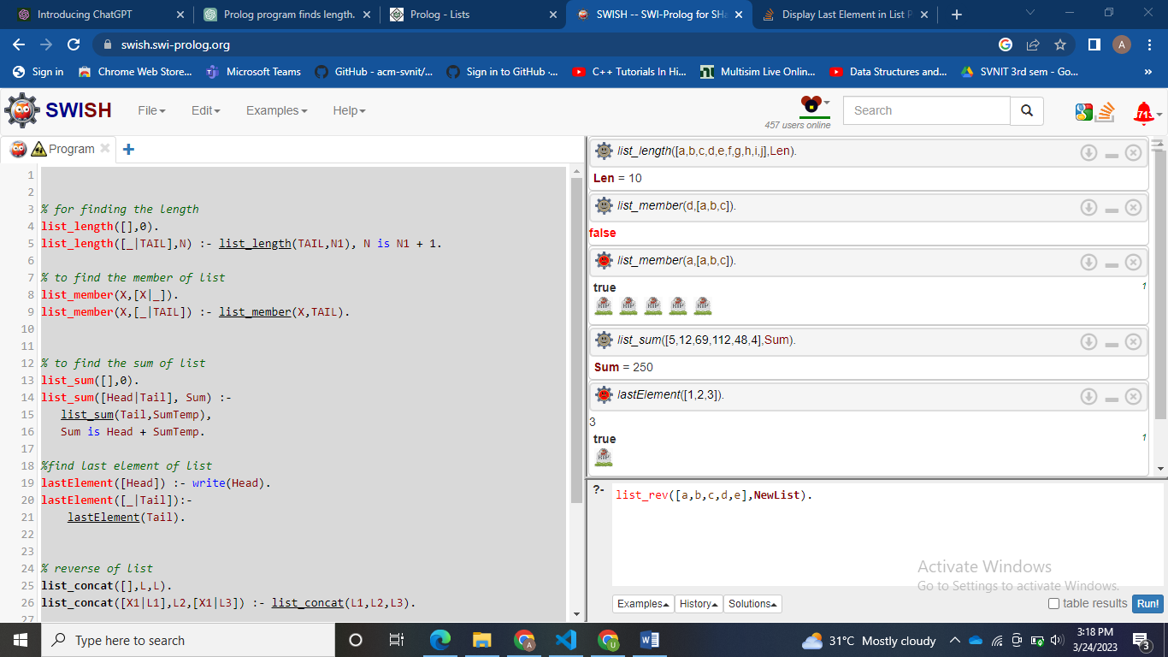

**2.**

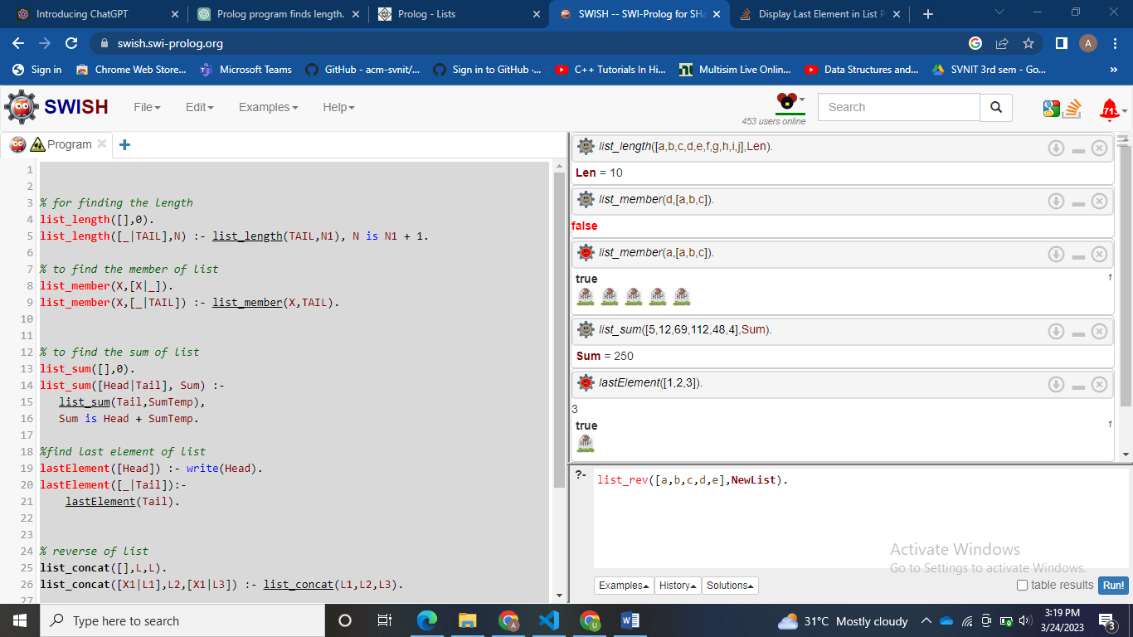

**3.**

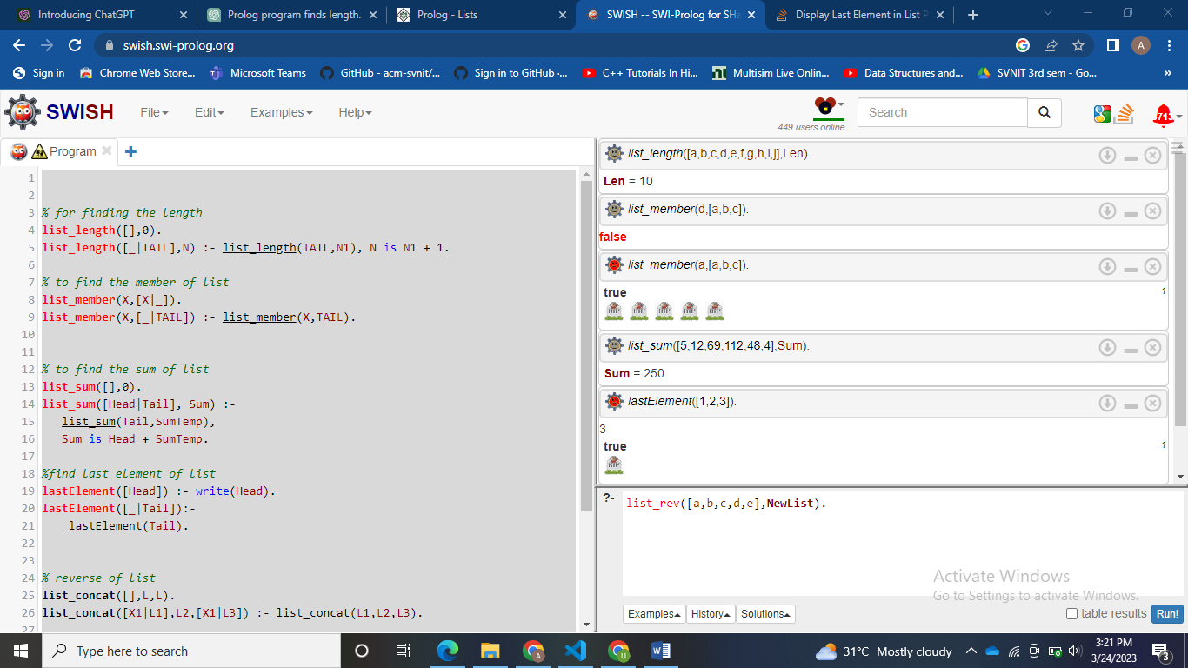

**4.**

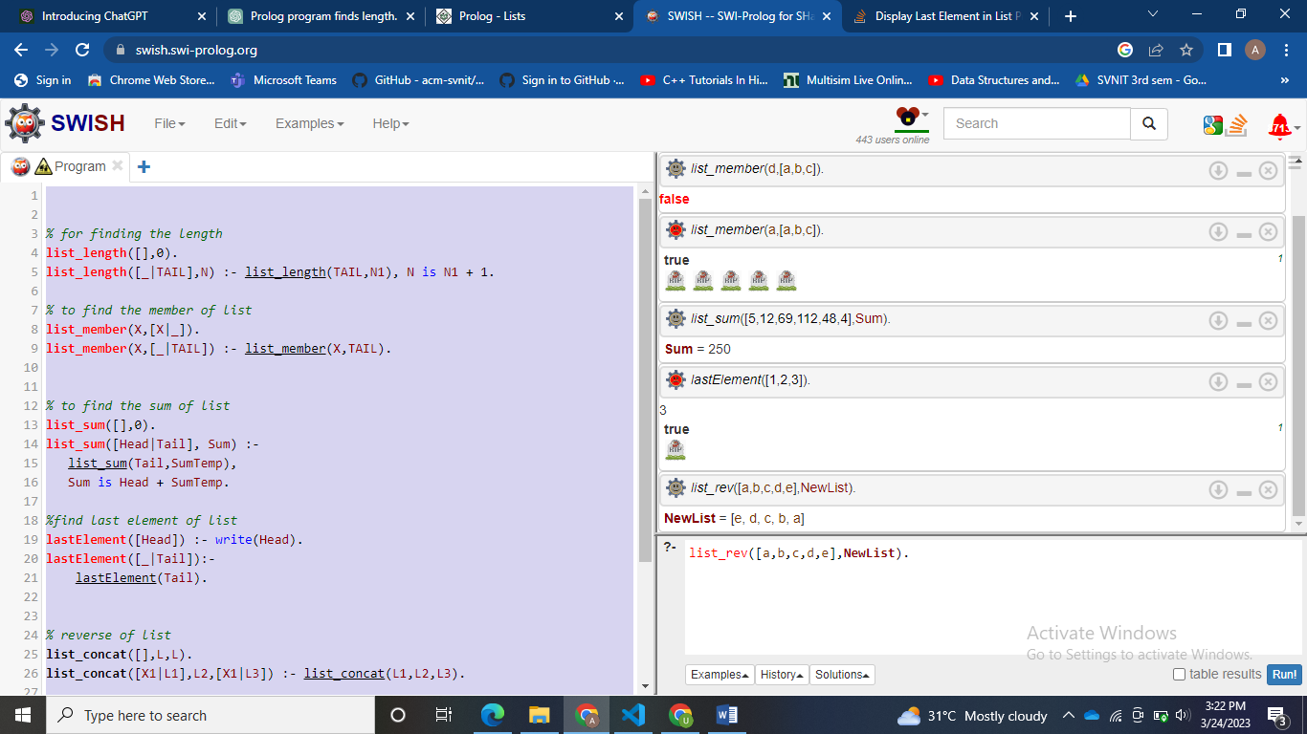

**5.**

